**SATIRE PRACTICE**

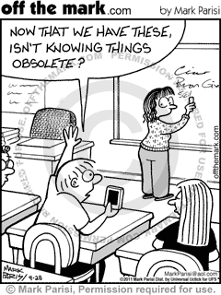

1. What type of Satire is this an example of?
2. What social issue is it commenting on?
3. Do you think it is effective at relaying its message? Why or why not?